User Manual for Bootleg osu!

By: Stephen Guo

Launch the program from the Launcher.java class

You will be introduced into the game, then booted into the menu. Here you will find 4 Options for the game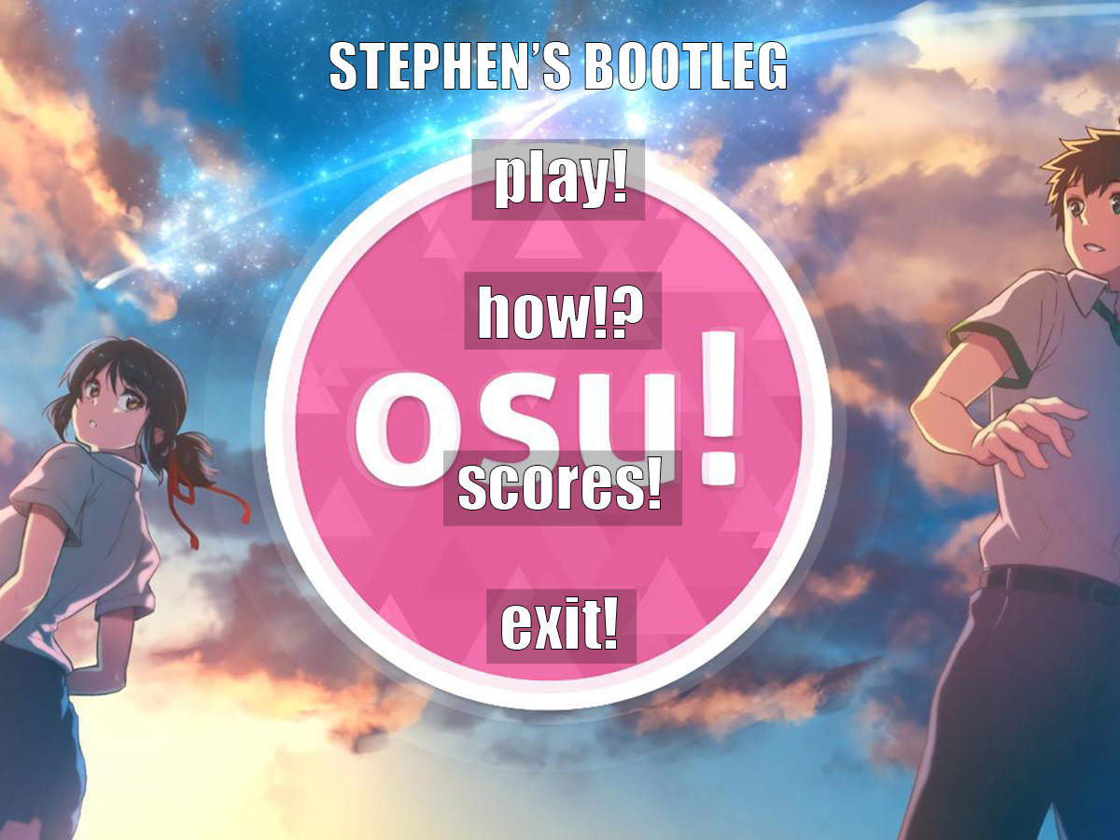

The exit button will just boot you out of the game

The scores screen will show the top 6 scores from the past people who played this game. Currently, there may be no one on the scores yet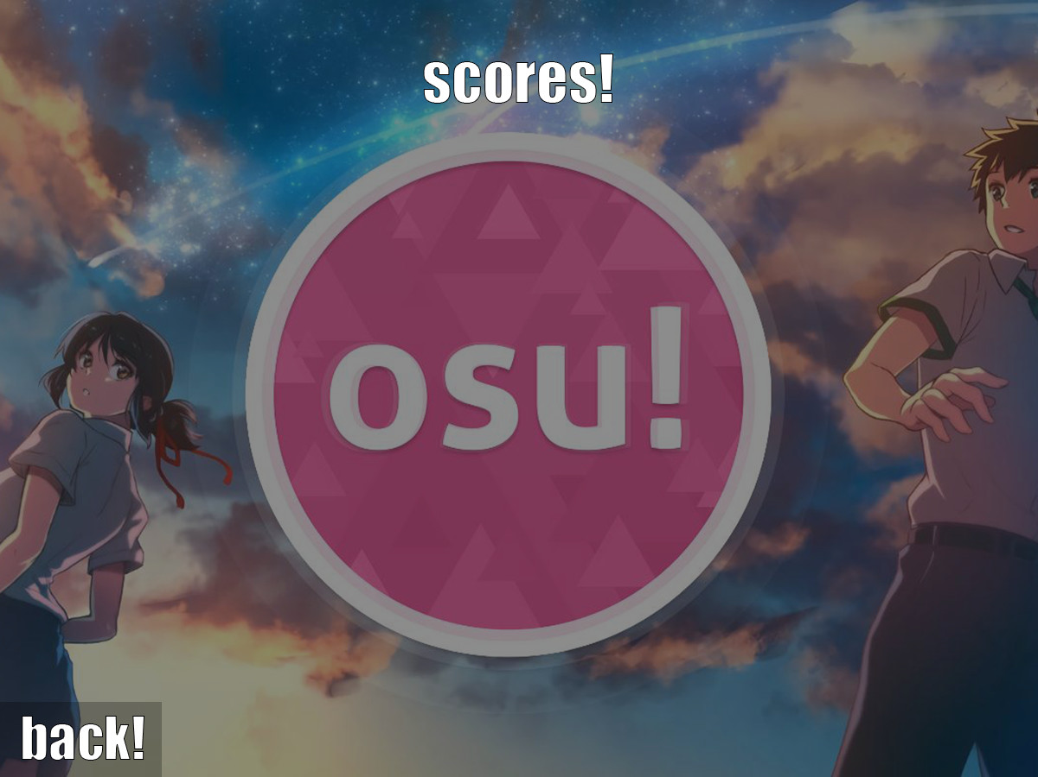

The how to play screen will just teach you how to play the game

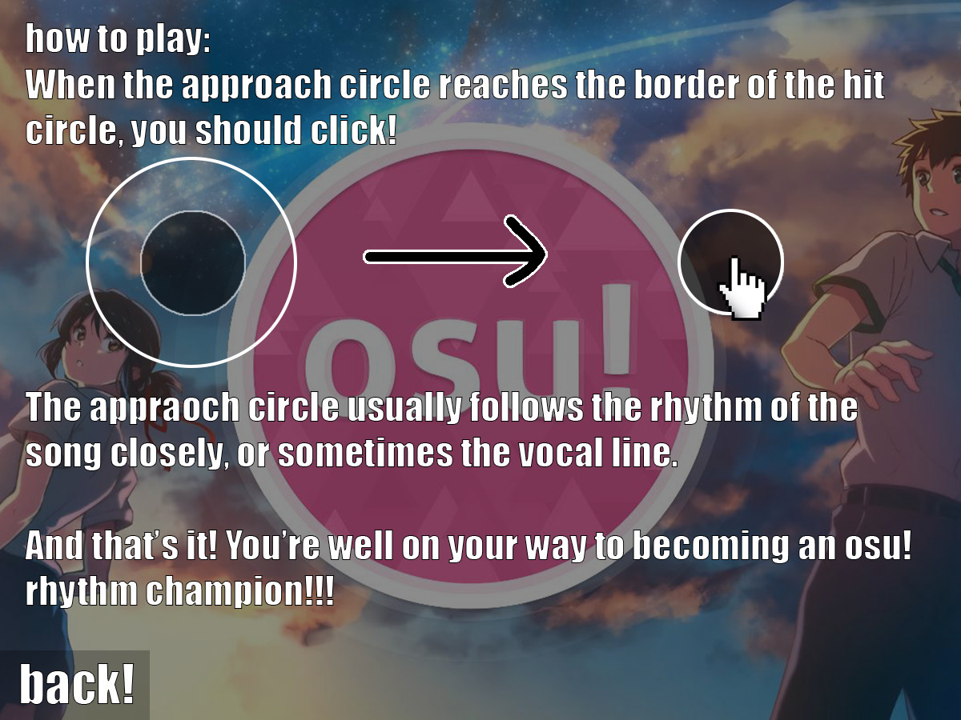

Lastly, there is a button to start playing the game

Here, the music will start playing and you have to aim to get the highest score you can!

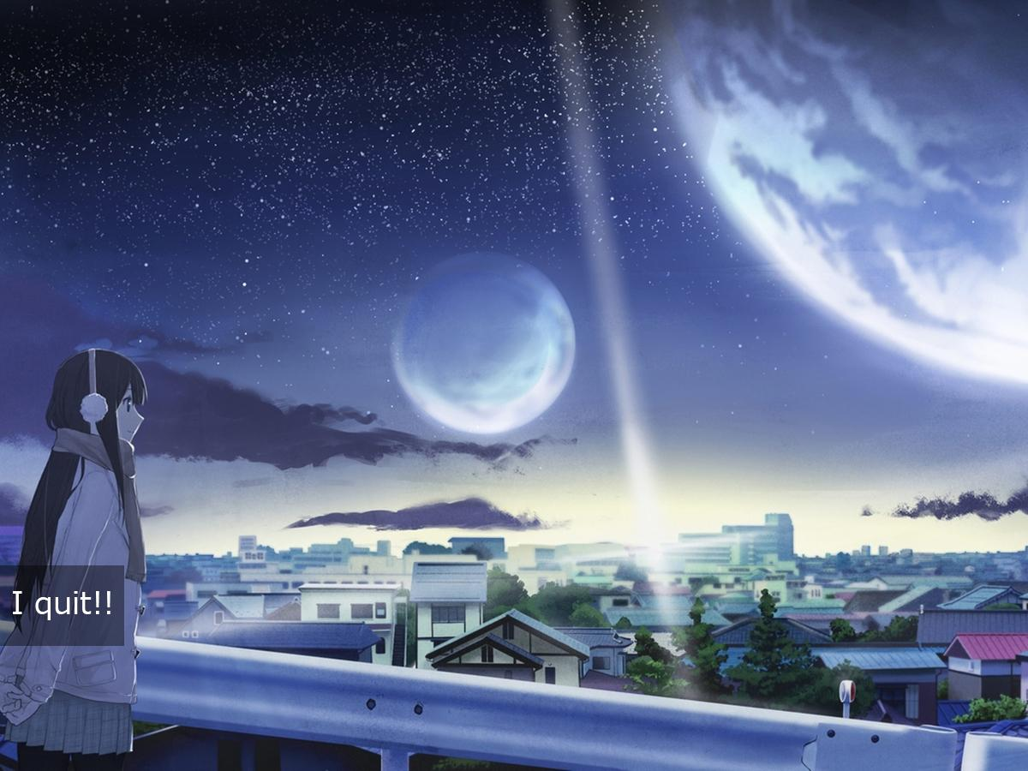

If you manage to get a top score, you will be asked for you name for your place in the leaderboards!

And that’s it! You’re well on your way to becoming an osu! rhythm champion!